Atharva Yadav

Roll No. 127

Batch : s23

Network Lab Assignment 4

AIM: Network topology using UDP protocol.

User Datagram Protocol (UDP) is a Transport Layer protocol. UDP is a part of the Internet Protocol suite, referred to as UDP/IP suite. Unlike TCP, it is an unreliable and connectionless protocol. So, there is no need to establish a connection before data transfer. The UDP helps to establish low-latency and loss-tolerating connections over the network. The UDP enables process-to-process communication.

# Advantages of UDP

Speed: UDP is faster than TCP because it does not have the overhead of establishing a connection and ensuring reliable data delivery.

Lower latency: Since there is no connection establishment, there is lower latency and faster response time.

Simplicity: UDP has a simpler protocol design than TCP

Broadcast support: UDP supports broadcasting to multiple recipients

Smaller packet size: UDP uses smaller packet sizes than TCP, which can reduce

Ring topology is a network architecture in which devices are connected in a ring structure and send information to each other based on their ring node's neighbouring node. As compared to the bus topology, a ring topology is highly efficient and can handle heavier loads. Because packets may only travel in one direction, most Ring Topologies are referred to as one-way unidirectional ring networks. Generally, Bidirectional and Unidirectional are the two types of ring topology. On the basis of devices that are being linked together to form a network, several kinds of ring topology setups work differently.

CODE: set ns [new Simulator]

$ns rtproto DV

set nf [open out.nam w]

$ns namtrace-all $nf

proc finish {} { global ns nf $ns flush-trace close $nf exec nam out.nam exit 0

}

#Creating Nodes for {set i 0} {$i<7} {incr i} { set n($i) [$ns node]

}

#Creating Links for {set i 0} {$i<7} {incr i} {

$ns duplex-link $n($i) $n([expr ($i+1)%7]) 512Kb 5ms DropTail

}

$ns duplex-link-op $n(0) $n(1) queuePos 1

$ns duplex-link-op $n(0) $n(6) queuePos 1

#Creating UDP agent and attching to node 0 set udp0 [new Agent/UDP] $ns attach-agent $n(0) $udp0

$ns attach-agent $n(0) $udp0

#Creating Null agent and attaching to node 3 set null0 [new Agent/Null] $ns attach-agent $n(3) $null0

$ns connect $udp0 $null0

#Creating a CBR agent and attaching it to udp0 set cbr0 [new Application/Traffic/CBR]

$cbr0 set packetSize_ 1024

$cbr0 set interval_ 0.01

$cbr0 attach-agent $udp0

$ns rtmodel-at 0.4 down $n(2) $n(3)

$ns rtmodel-at 1.0 up $n(2) $n(3)

$ns at 0.01 "$cbr0 start"

$ns at 1.5 "$cbr0 stop"

$ns at 2.0 "finish"

$ns run

OUTPUT:

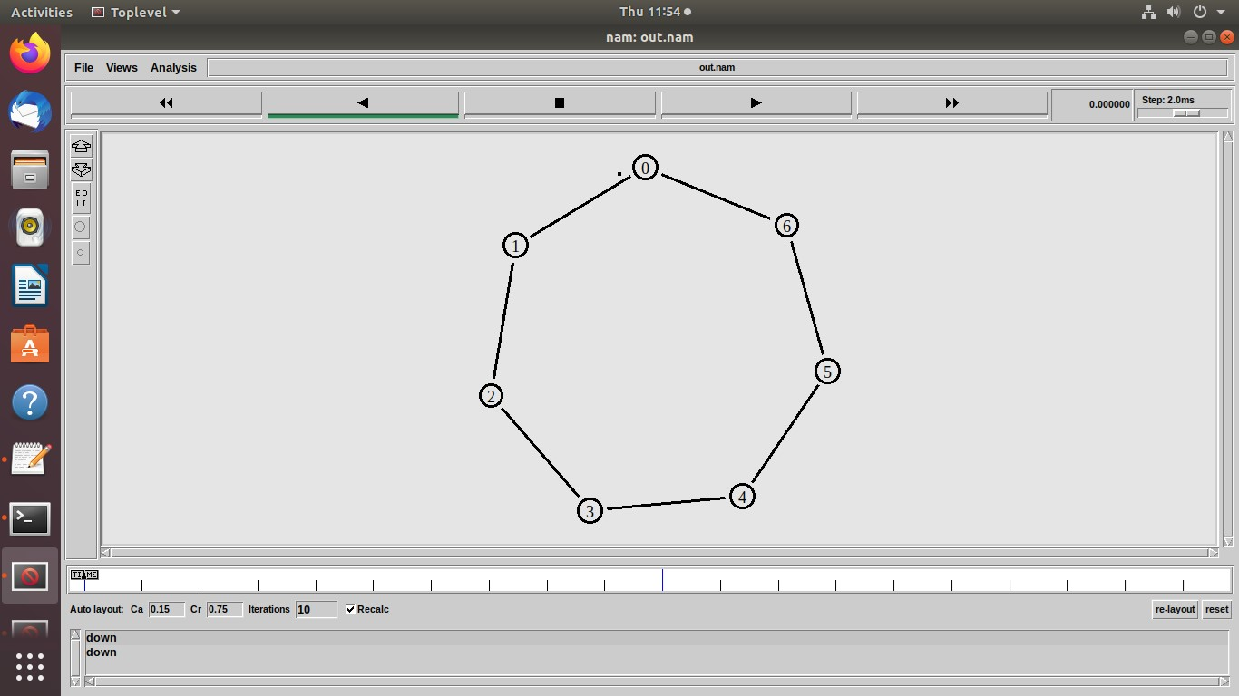

Conclusions: efficiency. Keep practicing to explore different network topologies and how they interact with UDP. This will help you network designs. choose the right protocol and network structure for various communication needs, ensuring optimal performance in your implementing UDP in a specific topology, We gained valuable experience in designing networks that prioritize speed and ideal for applications where real-time data delivery is crucial, even if some packets might be lost. By successfully bus, or mesh) and implemented UDP (User Datagram Protocol) within it. UDP prioritizes speed over reliability, making it trade-offs between different protocols in network design.WE explored configuring a chosen network topology .

LO: Based on LO3 : To understand the network simulator environment and visualize a network topology and observe its performance